Royal Courts of Justice hearing lists style guides
Venue: Royal Courts of Justice
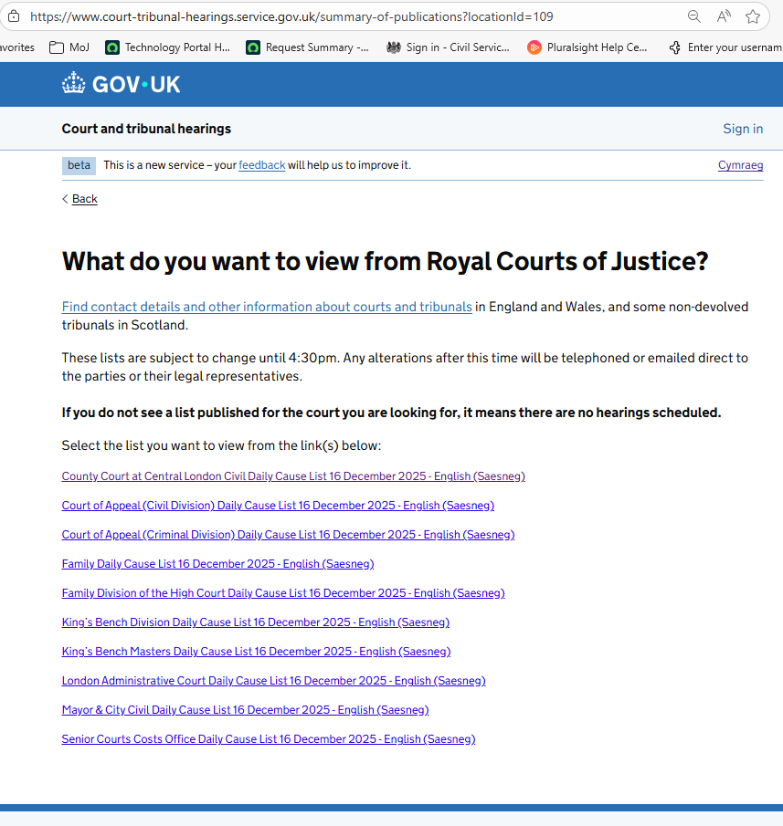

County Court at Central London Civil Daily Cause list
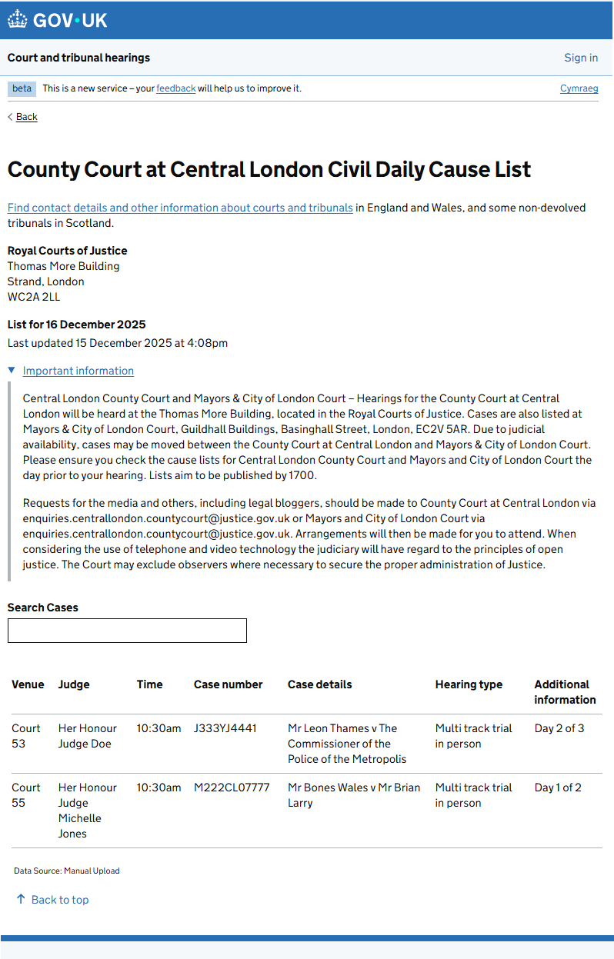

Court of Appeal (Civil Division) Daily Cause List
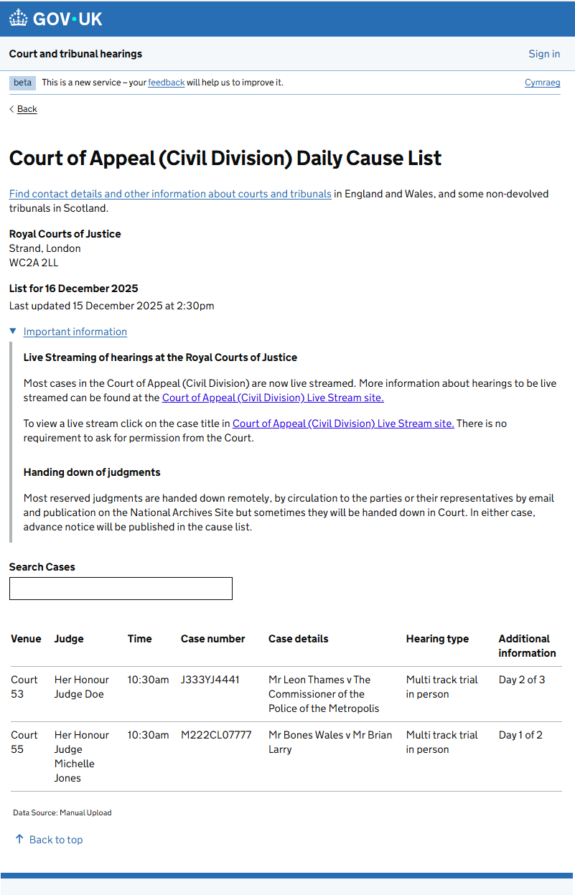

Court of Appeal (Criminal Division) Civil Daily Dause List
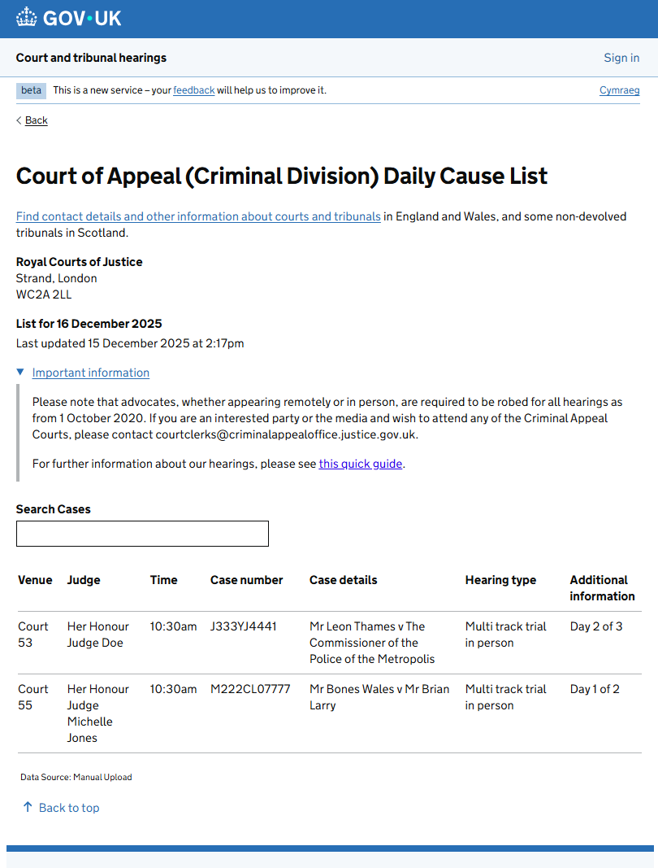

Family Daily Cause List for Royal Courts of Justice
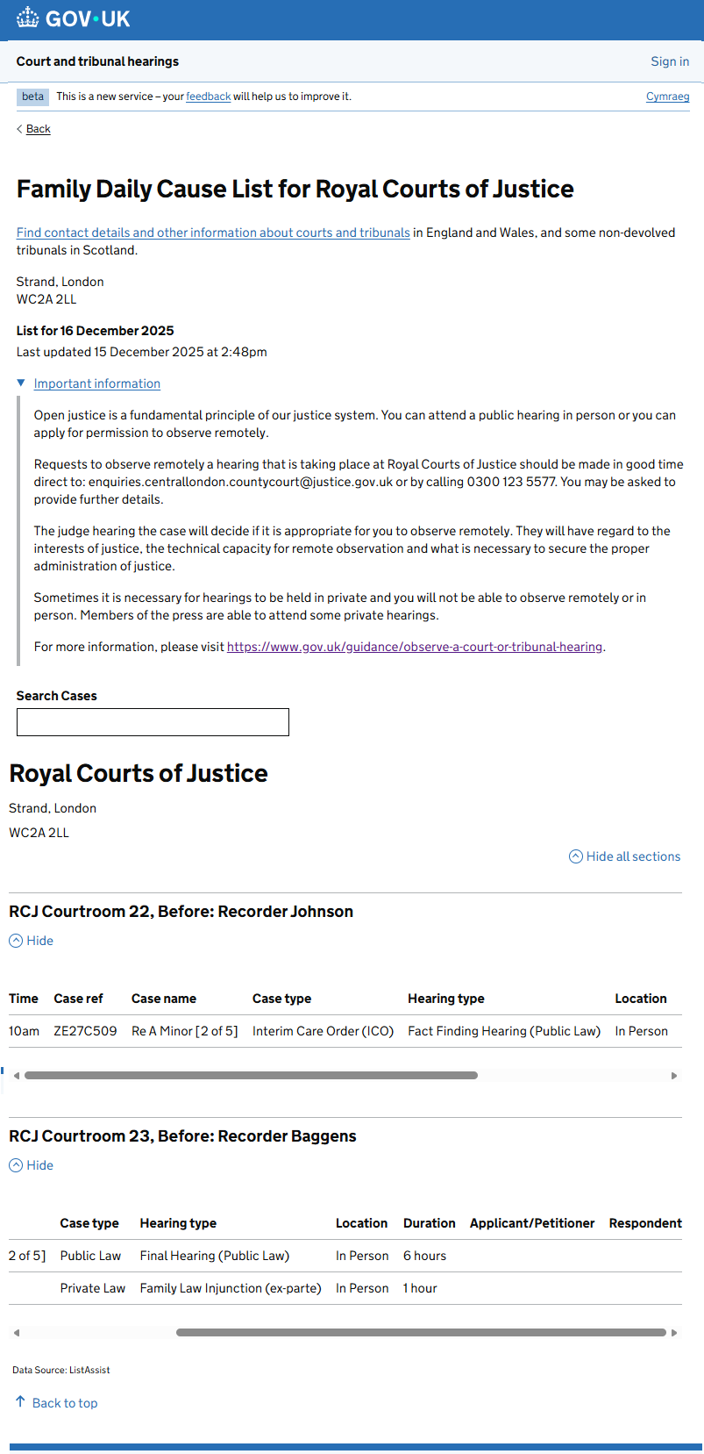
Family Division of the High Court Daily Cause List
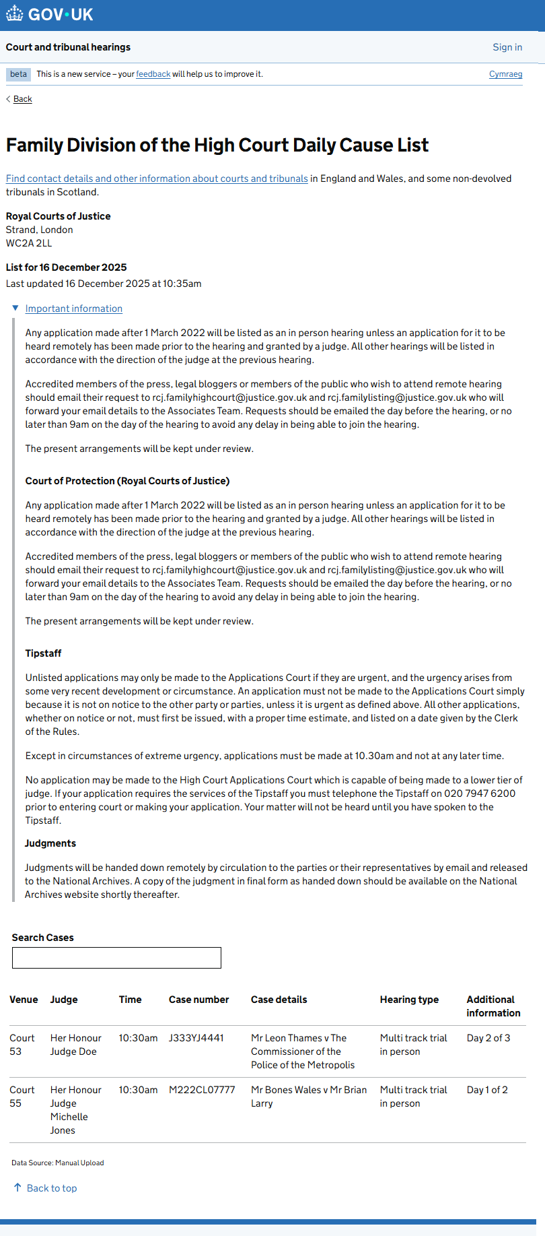

King’s Bench Division Daily Cause List
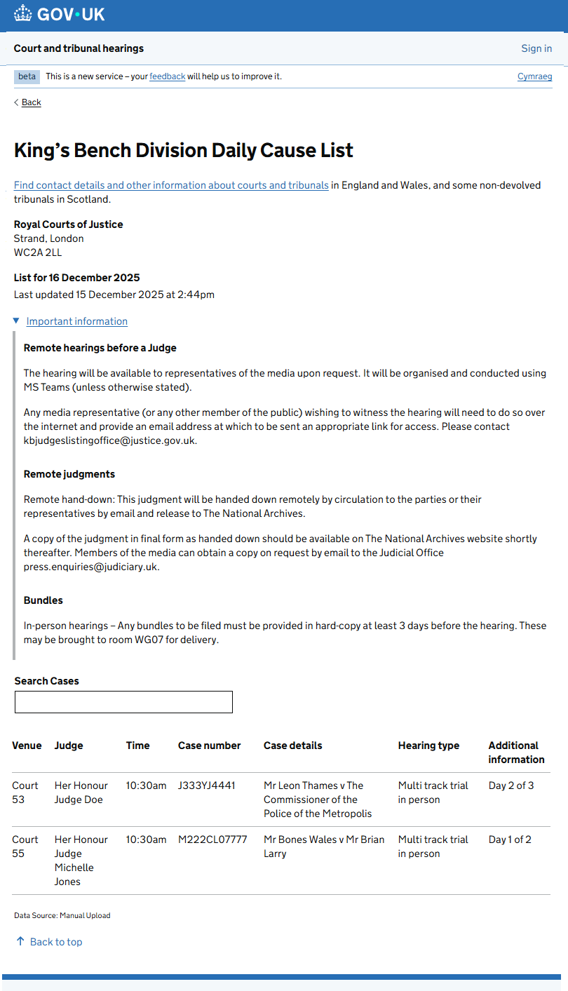

King’s Bench Masters Daily Cause List
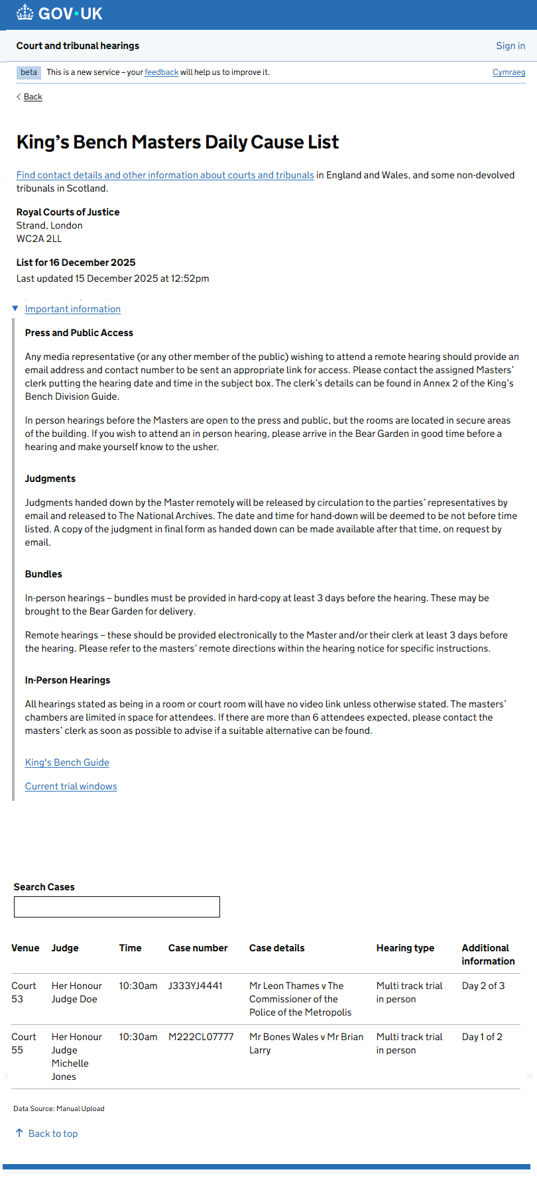

London Administrative Court Daily Cause List
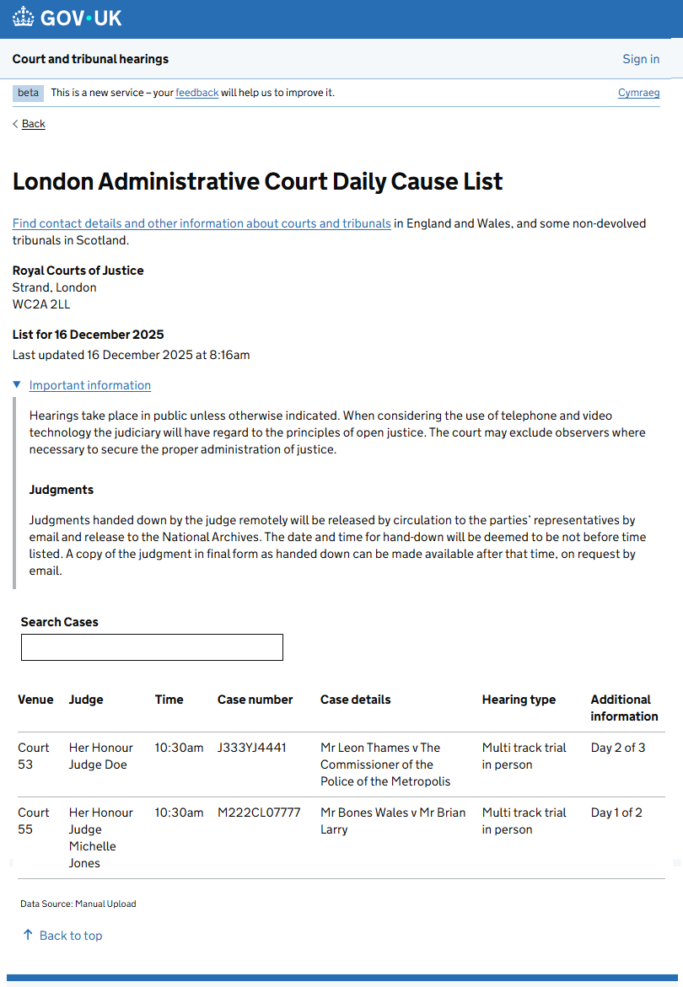

Mayor & City Civil Daily Cause List
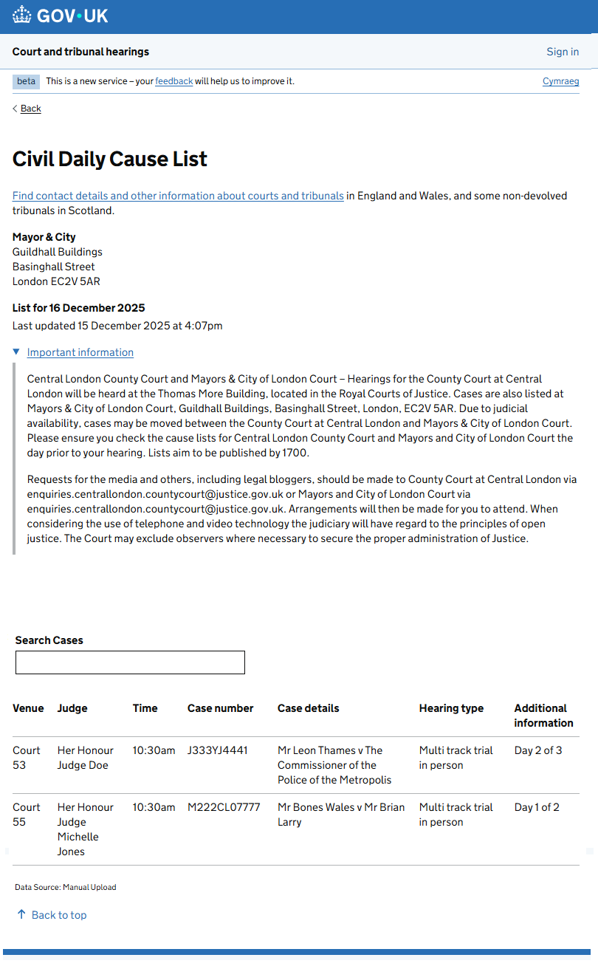

Senior Courts Costs Office Daily Cause List
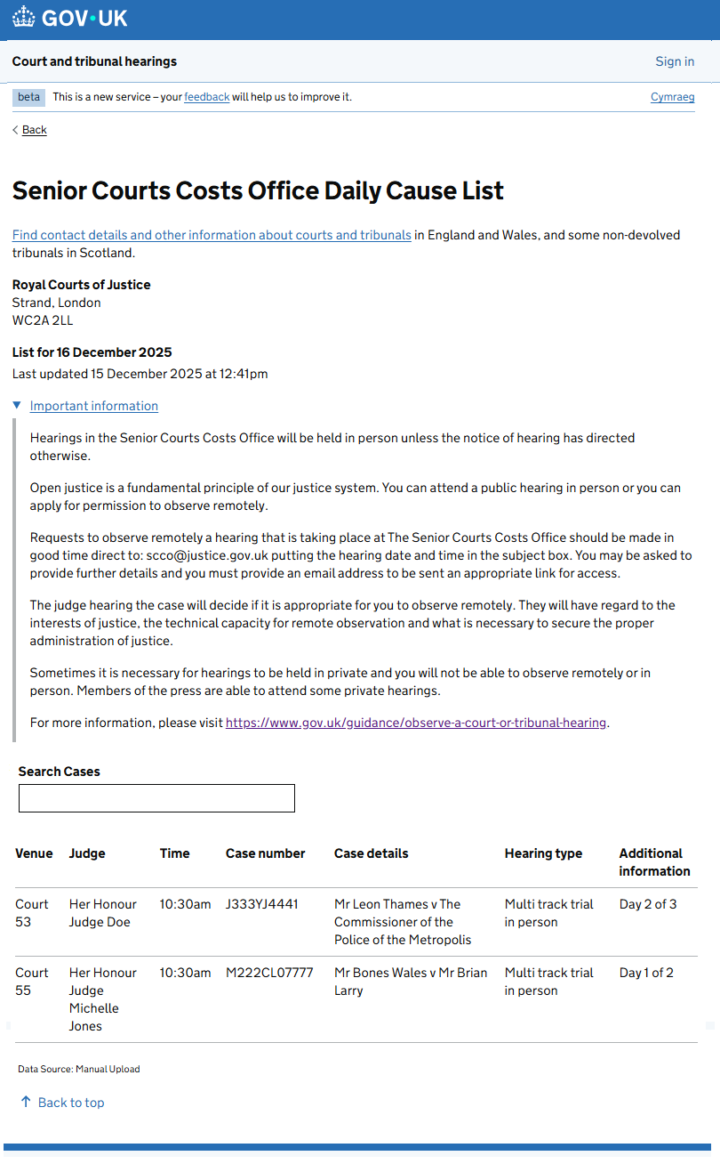

Birmingham Administrative Court Daily Cause List
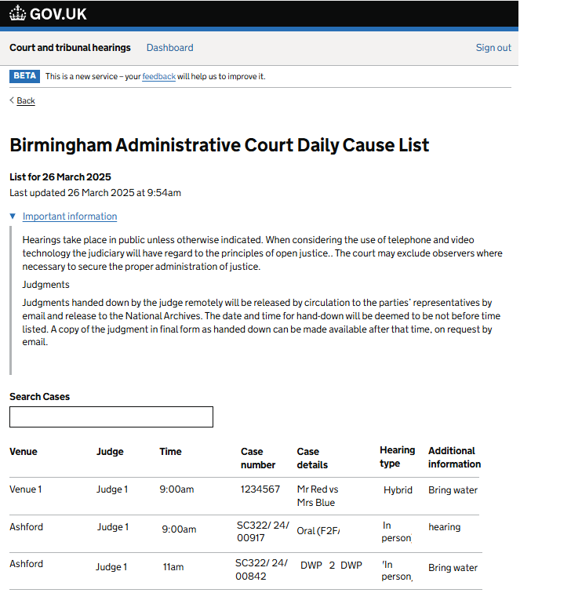

Manchester Administrative Court Daily Cause List
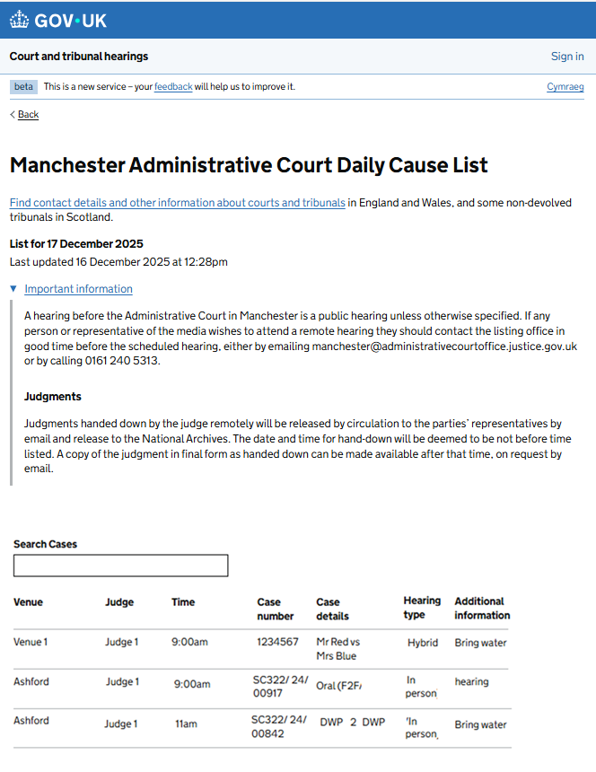

Bristol and Cardiff Administrative Court Daily Cause List
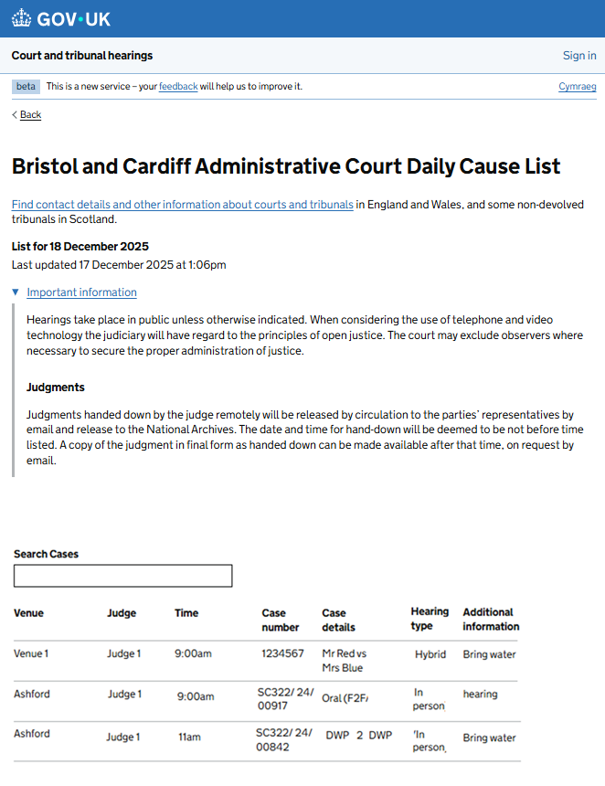

Leeds Administrative Court Daily Cause List
